**Overview of IS**

• Definition of IS

* An information system collects, processes, stores, analyzes and disseminates information for a specific purpose (to support individual, group, organizational and/or societal goals).
* Hardware, telecommunication, software, people, process, databases

• Fundamentals of people, process and technology

• General topic areas of IS

• Concepts from Gallaugher Chapter 1 (particularly concepts in the ‘Tech’s Tectonic Shift: Radically

Changing Business Landscapes’ section)

* The rise of **open source** software has lowered computing costs for startups to blue chips worldwide.
* **The growth of privacy concerns** is a radical change brought about by new technologies
* *Data analytics and business intelligence are creating a shifting knife-edge of privacy concerns that can shred corporate reputations if mishandled. And the pervasiveness of computing has created a set of security and espionage threats unimaginable to the prior generation.*
* **Data analytics and business** Intelligence are driving discovery and innovation, redefining modern marketing, and creating a shifting knife-edge of privacy concerns that can shred corporate reputations if mishandled.
* *Many organizations today collect and seek insights from massive datasets, which are often referred to as "Big Data." Data analytics and business intelligence are driving discovery and innovation, redefining modern marketing, and creating a shifting knife-edge of privacy concerns that can shred corporate reputations if mishandled.*
* *Cloud computing and software as a service are turning sophisticated, high-powered computing into a utility available to even the smallest businesses and non-profit organizations.*
* Uber/Airbnb owns no inventory of infrastructures (cars, houses)
* **Social media is cited as raising the ethics and service bar for modern managers**
* *Today, open source software powers most of the websites you visit. The rise of open source has rewritten the revenue models for the computing industry and lowered computing costs for startups to blue chips worldwide.*
* firms that collectively pay thousands of programmers to write code that is then given away for free
* In the previous decade, tech firms have created profound shifts in the way firms advertise and individuals and organizations communicate.
* New technologies have fueled globalization, redefined our concepts of software and computing, crushed costs, fueled data-driven decision-making, and raised privacy and security concerns.
* Recognize that anyone reading this book has the potential to build an impactful business. Entrepreneurship has no minimum age requirement.
* The ranks of technology revolutionaries are filled with young people, with several leading firms and innovations launched by entrepreneurs who started while roughly the age of the average university student.
* Several forces are accelerating and lowering the cost of entrepreneurship. These include crowdfunding, cloud computing, app stores, 3D printing, and social media, among others.
* *We're in a golden age of tech entrepreneurship where "the cloud" means a startup can rent the computing resources one previously had to buy at great expense.*
* *App stores give code jockeys immediate, nearly zero-cost distribution to a potential market of hundreds of millions of people worldwide.*
* As technology becomes cheaper and more powerful, it pervades more industries and is becoming increasingly baked into what were once nontech functional areas.
* Technology is impacting every major business discipline, including finance, accounting, marketing, operations, human resources, and the law.
* Tech jobs rank among the best and highest-growth positions, and tech firms rank among the best and highest-paying firms to work for.
* Information systems (IS) jobs are profoundly diverse, ranging from those that require heavy programming skills to those that are focused on design, process, project management, privacy, and strategy.
* Search engine marketing (SEM), search engine optimization (SEO), customer relationship management (CRM), and personalization systems are all central components of the new marketing toolkit.
* An organization's IS department ensures that systems get built and keep running. It also takes on strategic roles targeted at proposing solutions for how technology can give the firm a competitive edge.
* Experts in the area of strategy specialize in technology for competitive advantage.
* Technology experts in the area of UI design work to make sure systems are intuitive and easy to use

Types of IS

• Components of IS and systemic effects

* IS components are interdependent and socio-technical
* Changing one part can affect others
* Success based on proper interactions

• Case examples: JFK airport’s, McDonald’s and Applebee’s iPad implementations

* JKF airport implemented different entertainment tablets
* Applebee’s have tablet orders
* McDonald’s tablet initially did not succeed, but not they are trying to change
  + Because people are trying to get fast food and don’t have time to use the tablets

• Analysis of Postman’s five rules of technological change from the Postman article

* Technological change has trade offs – with each advantage there is a disadvantage – culture pays a price
* Advantages/Disadvantages never distribute evenly – every technology benefit some and harm some
  + Losers: Laypeople’s private information more accessible to big firms
  + Winners: Big firms
* Tech is not neutral, they are powerful ideas
* Tech change is ecological, changes everything, does not just add – red dye
* Tech is not mythic (part of natural world), is man made

• Definition, key benefits, and key risks of:

- Business Intelligence (BI) Systems (Google Analytics)

- use data and analytics to inform business strategy and decision-making

-adv: increase employee efficiency

- disadv: polluted data, hard to think creatively

-winners/losers

- Customer Relationship Management (CRM) Systems (Salesforce)

- A system to manage the company’s interactions with its current and potential customers for the focus on customer retention.

-Adv: Consistency with customer data. Reduced costs of mismarketing, can access data anywhere

-Disadv: security concerns – leak sensitive customer data, data entry expensive and time-consuming

-relate to winners/losers, laypeople data are being tracked

- Enterprise Resource Planning (ERP) Systems (Workday)

- help integrate the workflow of a company by creating a centralized database and interface for every facet of the business

- Centralized systems that collects, tracks, and organizes integrated data to efficiently organize a business

- Adv: make data access and everyday operation efficient; each part is connected? Make accounting more efficient

- Risk: costly

- Relates to tradeoffs, can be efficient but costly

- Geographic Information Systems (GIS) (Google Maps)

- Systems that capture and display spatial/geographic data

- adv: maximize resources, make accurate predictions to increase efficiency

-Disadv: expensive, being tracked constantly

-relate to #5, without GPS people cannot find ways to destinations

- Point of Sale (POS) Systems (Square Up)

- A system that manages transactions between organizations and customers, and the methods of payment.

-Adv: removes price tags, easier to track inventory, and manage profits better. Automatic data collection

-Disadv: security breaches, susceptible to cyber attacks, gather sensitive info from customers

-Winners/losers- customer more pressured to tip, small companies using this service has to pay a fee

- Supply Chain Management (SCM) Systems (Amazon)

- The management of the flow of goods and services across multiple organizations for product delivery. Monitors from the raw material acquisition to the delivery of the final good or service.

- Adv: manage quality; Eliminate waste; improve efficiency; helps with communication

-Disadv: small mistake leads to big consequence, need standardization, interrupt existing business model

-Relate to winners/losers because those who don’t have SCM cannot compete

• Concepts from Gallaugher Chapter 2 (particularly concepts of competitive advantage, value chain and

Porter’s five forces)

* 1) valuable; 2) rare; 3) imperfectly imitable (tough to imitate); and 4) nonsubstitutable.

IS and Business Strategy

• Definition of enterprise architecture and why it is important

* The description of the goals of an organization, how these goals are realized by business processes, and how these business processes can be better served through technology

• IS strategy triangle, value chain, Porter’s five forces

• Case examples: Coca-cola, and Zara (concepts from Gallaugher Chapter 3)

* Coca-Cola freestyle offers a big variety and keep tracks of data, fast SCM system,

ZARA:

* Zara concepts go from idea to stores in fifteen days on average.
* To achieve this high level of responsiveness, Zara uses:
* Combination of vertical integration and technology-orchestrated coordination

of suppliers.

* Just-in-time manufacturing.
* The majority of Zara’s merchandise is produced in-house, with an eye

on leveraging technology in areas that speed up complex tasks, lower

cycle time, and reduces errors.

* Inventory optimization models determine how many of which items
* in which sizes should be delivered to each specific store.

Security tags are custom made to also include RFID-technology. RFID

(Radio Frequency Identification) tags wirelessly emit a unique identifying

code for the individual item.

• Since the entire supply chain is under Zara control and all items flow through one of two warehouses, Zara can affix tags to all products before sending them out to stores

• RFID lets Zara know where products are, so if a customer asks for an item in a store, staff using custom apps on an iPod Touch can immediately tell if a product is in store, in a nearby store, or if it can be ordered from the distribution center or Zara.com.

• RFID tags also allow Zara staff to take in-store inventory four times as often as the pre-RFID rate, with greater accuracy, and using one forth the staff

-Zara’s store managers are armed with custom apps on mobile devices (initially personal digital assistants (PDAs) now touch screen iPods).

• Used to gather customer input and feedback.

• Point-of-sale-system (POS): Transaction processing system that captures customer purchase information.

• Shows how garments rank by sales.

• Managers use the information gathered from these systems to make decisions more quickly and more accurately.

• Customer demand and sales data dictate the designs that Zara develops. Inditex see e-commerce as a critical part of the firm's omnichannel strategy, which blends online and offline sales in ways that best

benefit the customer.

• The company sees the link between online and off-line sales as being so fluid, it doesn't even breakout online sales as a separate category.

• One-third of online orders are scheduled for in-store pickup.

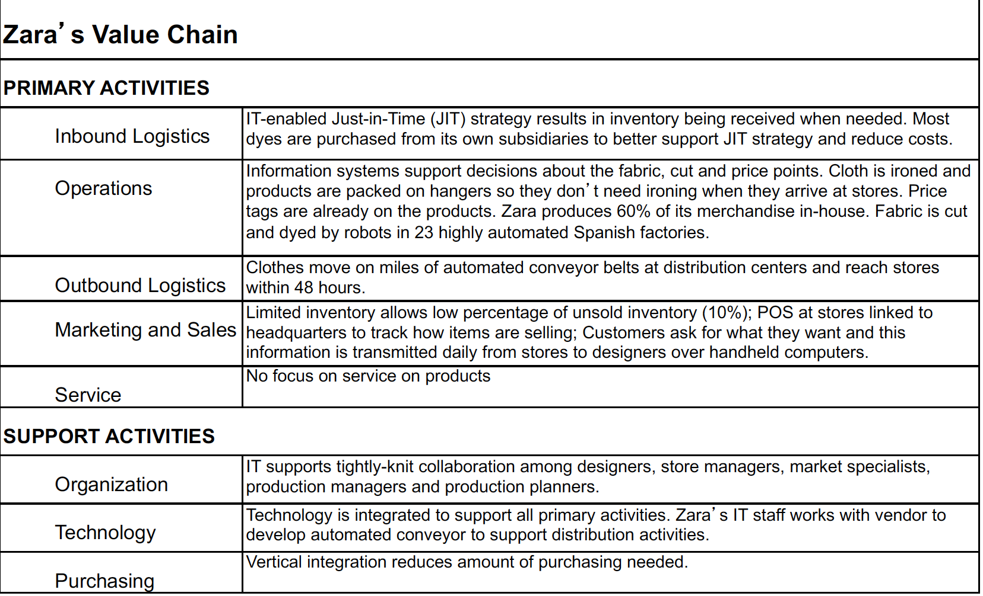

Gaining Competitive Advantage with IS

• Ways IS can help gain competitive advantage

• Models of strategic intent (value discipline model, IS strategy triangle and decision filters for

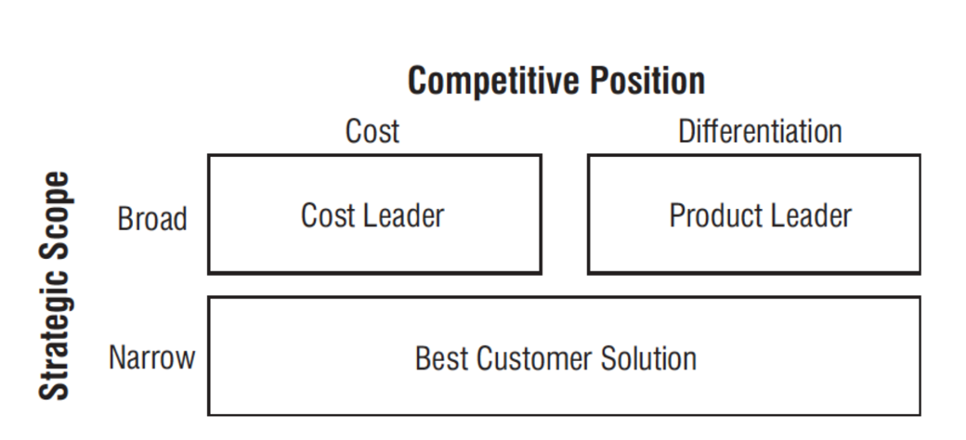prioritizing IS projects)

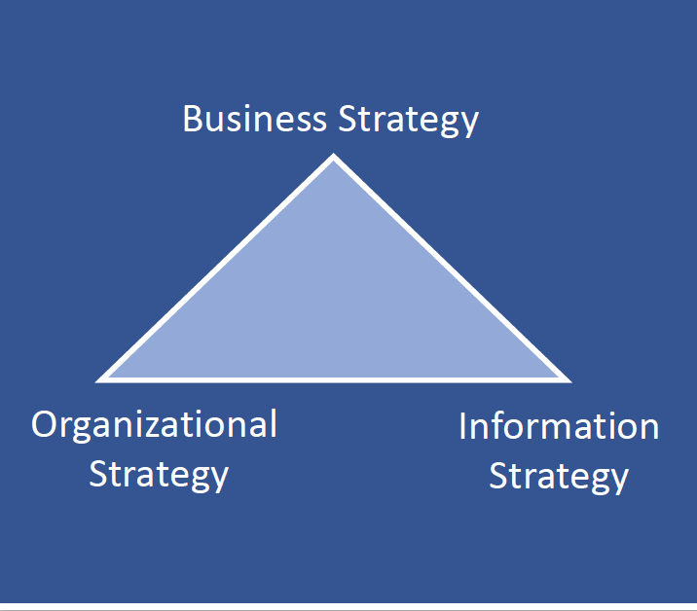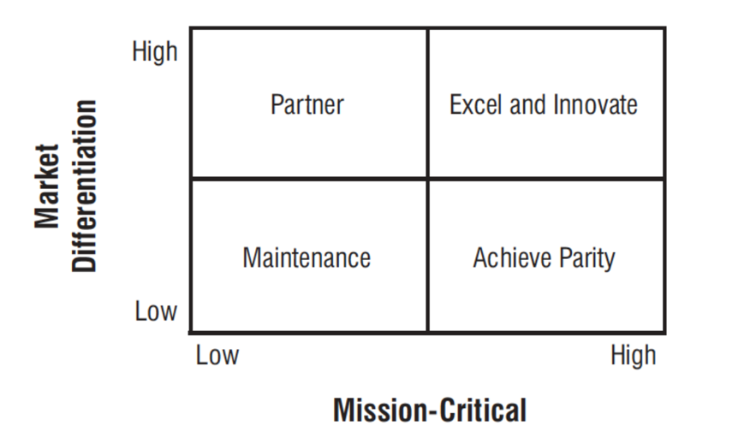

* business have overarching business strategy that drives organizational and information strategy
* changes in any strategy requires changes in others to make balance
* always involves consequences

• Case example: Netflix (concepts from Gallaugher Chapter 4)

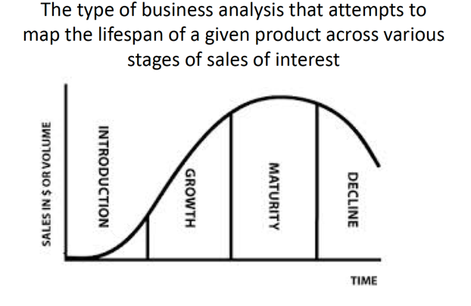Innovation and Business Process Reengineering

• Industry compression and vertical integration concepts, the product lifecycle and Moore’s Law

(concepts from Gallaugher Chapter 5 particularly the sections on ‘The Death of Moore’s Law?’ and

‘Mickey’s Wearable: Disney’s Magic Band’)

* Moore’s Law: computing process power per dollar doubles every 18 months
* Price elasticity: demand of product fluctuates with price change

• Innovation and disruptive innovation (concepts from Gallaugher Chapter 6 particularly the

‘Introduction’)

* innovation is people creating values by implementing new ideas (ideation+implementation)
* sustaining and enabling innovations - make existent products better
* Disruptive Innovation – NEW stuff, originally not important

• Purpose and use of modeling / activity diagrams

* Business process: a set of activities to achieve certain task – transform inputs to outputs, include: beginning/end, input/output, a set of tasks to do the transformation, metrics for measuring effectiveness
* Square: activity Diamond:decision point Upsidedown Trapezoid: manual process Start/End state

Globalization, eCommerce and the Sharing Economy

• Network effects (definition, value, structures and competitive strategies) (concepts from chapter 8)

* Value of network effect comes from:
  + Exchange in creating values, staying power, complementary benefits
* One-sided market: same side exchange benefits
* Two-sided market: cross-side benefits
* competition at the beginning very fierce because leader becomes dominant

• Case example: Amazon.com (concepts from Gallaugher Chapter 7)

Software Development and Project Management

• Characteristics of successful, challenged or failed projects

• Concepts from the DePalma article (definition of software engineering, why so many projects fail, the

Fallows framework, and why we may never have reliability)

* programmers have mils to go before earning the title “software engineering “
* engineering: logical, organized way to create a software

Software Development Methodologies and Modeling

• Definition and purpose of systems development lifecycle

* The process of understanding how IS supports business needs, designing the system, building it and delivering it to users and maintaining it
* Planning, analysis, design, development, testing, implement, maintenance

• Definition, purpose and primary tasks associated with each phase of the systems development

Lifecycle

* Planning phase (why)
  + Identify business value
  + Analyze feasibility
  + Develop workplan
  + Staff the project
  + Control and direct the project
* Analysis (who what where when)
  + Info gathering
  + Requirement determination
  + Process modeling (universal modeling language)
* Design (how)
  + Design strategy
  + Architectural, interface, database, program design
* Development, testing, implementation
  + Construction/coding, testing, installation, support plan
* Maintenance
  + resolve bugs, enhancement, upgrades

• Definition and purpose of systems development methodologies

* the specific approach used to conduct the steps of the SDLC that are necessary to plan, analyze, design, build, implement, and maintain information systems.

• Definition, advantages and disadvantages of various methodologies (refer to summarized class

discussion document in Canvas from February 11)

- Structured (waterfall, phased and parallel development)

- parallel – doing subprojects at the same time, but the some is still waterfall, then integrate

- phased – do one phase, check if works, then do another phase…

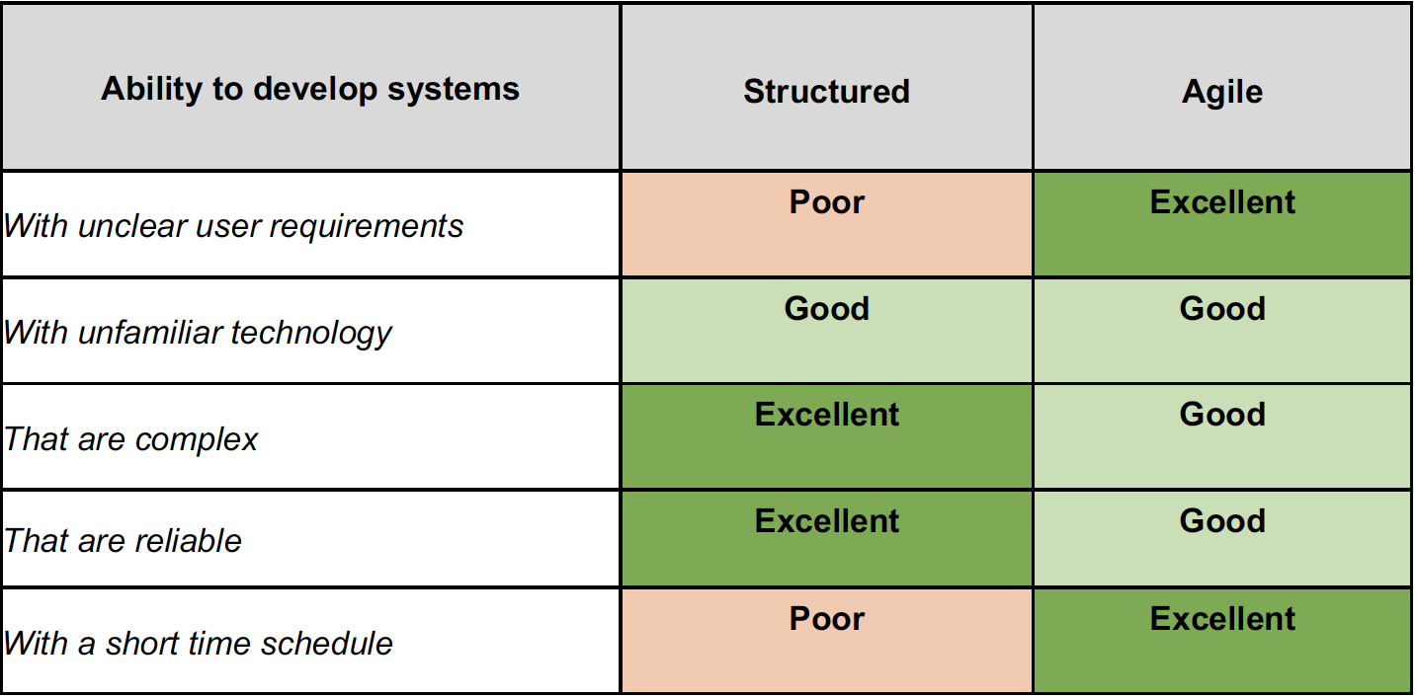 - Agile development (prototyping, extreme programming and SCRUM)

-scrum: have a sprint period of 1-4 weeks. Then regather.

-standup meetings

-A **scrum master** is the facilitator for an agile development team, product owner, development team

• Decision criteria for selection of particular methods

* agile more successful

• Differences between incremental and iterative approaches

-incremental: have a full picture, one bit at a time

- iterative: have an idea, do some for the whole thing, then refine the whole thing

• Ways in which the Marshmallow Challenge and the Ball Point game informs our understanding of the

SDLC (e.g., key take-aways and/or class discussion items)

* marshmallow represent structured – putting marshmallow last
  + prototype matters
  + hidden assumption of project
  + allow time for testing
* Ball point – Agile
  + Share common goal
  + Plan-do-check-act (PDCA) iterations
  + Fail fast
  + Scrumflow-challenge is doable if people not disturbed in an iteration and the work has a meaning

• Definition and value of UML used in a structured methodology (use case diagram and use case

description)

* activity diagrams, use case diagrams, use case description
* sequence diagram, ERD, wireframe

• Key principles, people, artifacts and meetings held with a SCRUM approach

• Definition and value of personas, FUBU, and user stories

* FUBU – for us by us
* Identify types of users -> profile user types -> personify user types -> identify product impact
* A user story is a brief statement of intent that describes something the system needs to do for the user
  + Understand user’s need and describe the product
  + As a (user), I can (do something), so I can (reach a goal)
  + Short and simple, from perspective of user
  + Have a success criteria
* Product backlog: a collection of functions for a product, most valuable on top
  + Express in user stories

The exam WILL include the following readings:

• Gallaugher Chapters 1-8

• Postman article

• DePalma article

* more people does not mean more productivity
* don’t understand the tool being used
* the vegematic promise: hybrid software with too many features to be learned
* the rosy prospect: almost done, “going well”
* big technical leap: using something never used before
* the unpleasant surprise: something really bad
* the house of cards: cause entire system to collapse
* We are unable to learn from mistakes
* Newer field with fewer experts
* Rapid changes in technology (Moore’s Law)
* Mythical Man Month (adding more people make projects slower)
* Developer and business expert communication (“interdependent parasitism”)
* Too ambitious of a timeline
* Lack of visibility (code walk through, timeline)
* Not wearing out / scope creep